**HOW TO AUTOMATE LOGIN PROCESS OF SKYPE :**

**Here I automate skype login with python selenium**

**Code for that:-**

import time

from selenium import webdriver

from selenium.webdriver.common.by import By

from selenium.webdriver.support.ui import WebDriverWait

from selenium.webdriver.support import expected_conditions as EC

driver = webdriver.Chrome() # Create a WebDriver instance (assuming you have a compatible driver installed, e.g., ChromeDriver)

driver.get("https://login.live.com/login.srf?wa=wsignin1.0&rpsnv=13&ct=1687171148&rver=7.1.6819.0&wp=MBI_SSL&wreply=https%3A%2F%2Flw.skype.com%2Flogin%2Foauth%2Fproxy%3Fclient_id%3D572381%26redirect_uri%3Dhttps%253A%252F%252Fweb.skype.com%252FAuth%252FPostHandler%253FopenPstnPage%253Dtrue%26state%3Dc754004a-d5be-4c1f-88ff-9ed2293fb4f1&lc=1033&id=293290&mkt=en-US&psi=skype&lw=1&cobrandid=2befc4b5-19e3-46e8-8347-77317a16a5a5&client_flight=ReservedFlight33%2CReservedFlight67") # Load the Instagram login page

time.sleep(5) # Wait for the page to load

username_input = WebDriverWait(driver, 10).until(

EC.visibility_of_element_located((By.XPATH, '//*[@id="i0116"]'))

) # Find the username input field using explicit wait

username_input.send_keys("srikarp@dikshasea.com") # Enter your username

next_button = WebDriverWait(driver, 10).until(

EC.element_to_be_clickable((By.XPATH, '//*[@id="idSIButton9"]'))

)

next_button.click()

password_input = WebDriverWait(driver, 10).until(

EC.visibility_of_element_located((By.XPATH,'//*[@id="i0118"]'))

) # Find the password input field using explicit wait

password_input.send_keys("Sridivya@2020") # Enter your password

password_input.submit() # Submit the login form

next_yesbutton = WebDriverWait(driver, 10).until(

EC.element_to_be_clickable((By.XPATH, '//*[@id="idSIButton9"]'))

)

next_yesbutton.click()

time.sleep(120) # Wait for the login process to complete

driver.quit() # Close the browser

driver.quit() # Close the browser

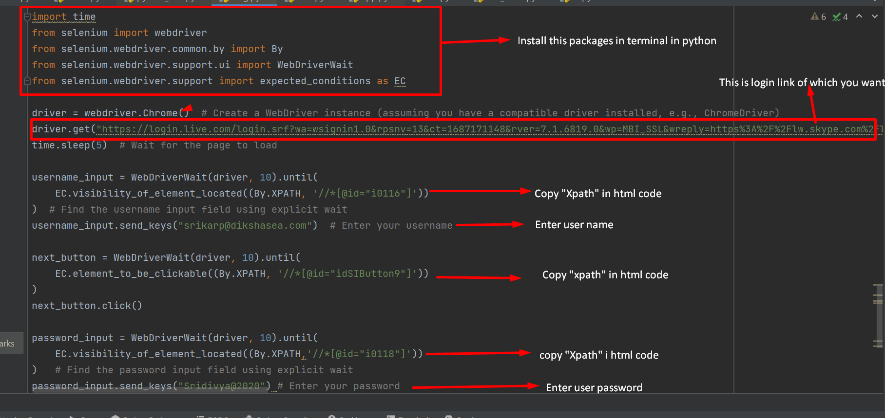

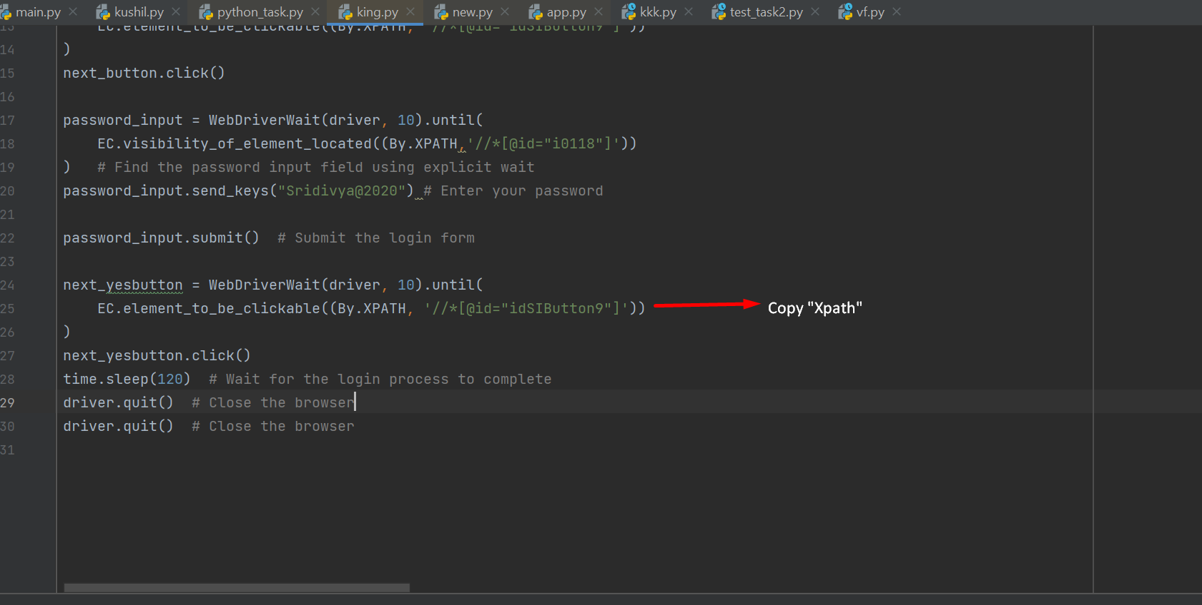

**THIS IS AUTOMATE LOGIN INSTAGRAM WEBSITE**

**CODE FOR THAT:-**

import time

from selenium import webdriver

from selenium.webdriver.common.by import By

from selenium.webdriver.support.ui import WebDriverWait

from selenium.webdriver.support import expected_conditions as EC

# Create a WebDriver instance (assuming you have a compatible driver installed, e.g., ChromeDriver)

driver = webdriver.Chrome()

# Load the Instagram login page

driver.get("https://www.instagram.com/")

# Wait for the page to load

time.sleep(5)

# Find the username input field using explicit wait

username_input = WebDriverWait(driver, 10).until(

EC.presence_of_element_located((By.XPATH, "//*[@id='loginForm']/div/div[1]/div/label/input"))

)

# Enter your username

username_input.send_keys("k6300624859@gmail.com")

# Find the password input field using explicit wait

password_input = WebDriverWait(driver, 10).until(

EC.presence_of_element_located((By.XPATH, "//*[@id='loginForm']/div/div[2]/div/label/input"))

)

# Enter your password

password_input.send_keys("kushil@123")

# Submit the login form

password_input.submit()

# Wait for the login process to complete

time.sleep(120)

# Close the browser

driver.quit()

# Close the browser

driver.quit()